**Project Initialization and Planning Phase**

|  |  |
| --- | --- |
| Date | 24 June 2024 |
| Team ID | 740709 |
| Project Name | House Rent Price Prediction Using Machine Learning |
| Maximum Marks | 3 Marks |

**Define Problem Statements (House Rent Price Prediction):**

In the real estate market, accurate prediction of rental prices is crucial for both tenants and landlords. For tenants, it helps in making informed decisions about housing affordability and budgeting. For landlords and property managers, it aids in setting competitive and fair rental prices to maximize occupancy and revenue.

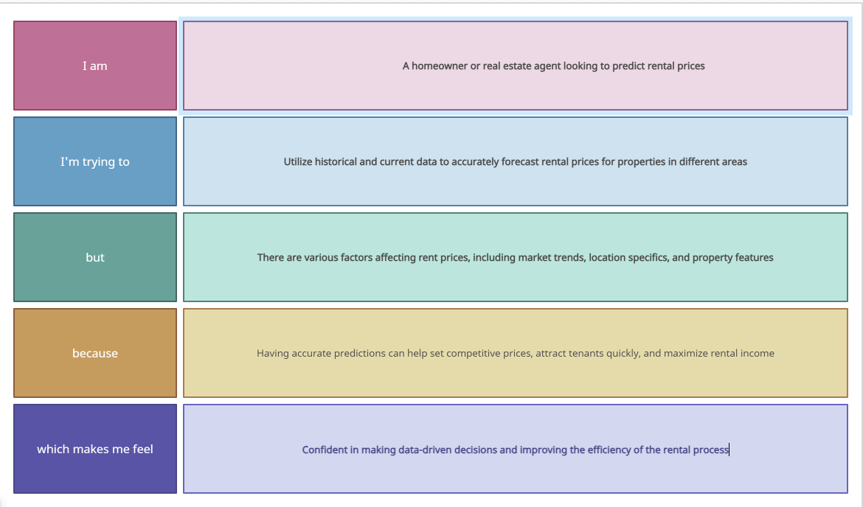

Example:

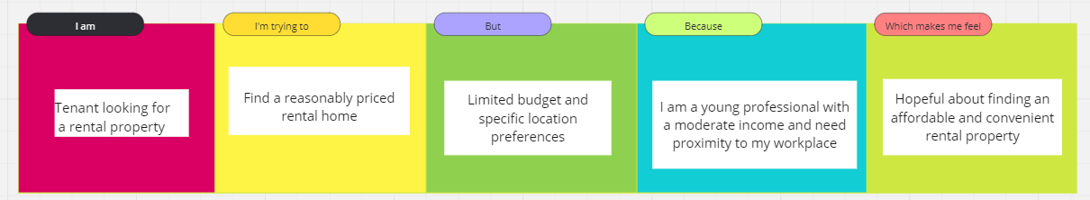

|  |  |  |  |  |  |
| --- | --- | --- | --- | --- | --- |
| **Problem**  **Statement**  **(PS)** | **I am**  **(Data Analyst/Real Estate Analyst)** | **I’m trying to** | **But** | **Because** | **Which makes me feel** |
| PS-1 | A real estate analyst (or data engineer, property manager, etc.) aiming to streamline rental price estimation.. | Develop an automated system that uses machine learning to predict house rent prices based on features like city, number of BHKS, bathrooms, square feet per inch, build-up area, type of property, location, and deposit description.. | The manual process is time-consuming and prone to errors, and existing automated systems do not account for all critical factors affecting rent prices. | A comprehensive and accurate prediction model is essential for making informed decisions and providing competitive rental prices in the market. | The need for an efficient, reliable, and comprehensive predictive system that can handle the complexities of real estate data. |

|  |  |  |  |  |  |
| --- | --- | --- | --- | --- | --- |
| PS-2 | A data analyst (or data scientist, researcher, etc.) looking to develop a predictive model. | Accurately predict monthly rent of a house using its characteristics such as city, number of BHKS, number of bathrooms, square feet per inch, build-up area, type of property,location. | The current predictions are not accurate enough and do not consider all the relevant features, leading to potential pricing errors and customer dissatisfaction. | The available data is complex and requires advanced techniques to extract meaningful patterns and relationships. | The need for a robust predictive model that can handle the complexity and provide reliable rent estimates. |